Atitit 游戏项目图片对比结果总结

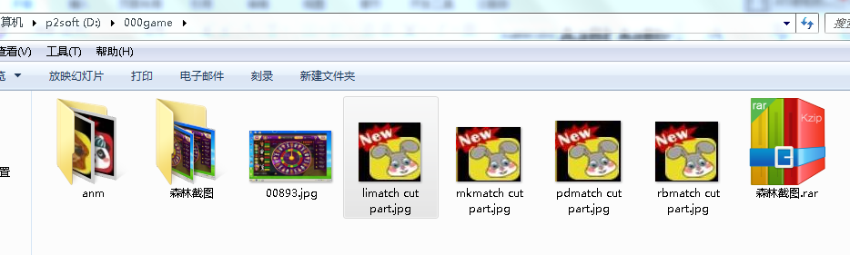

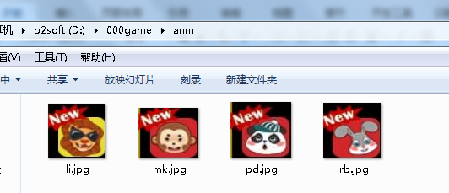

--load lib:D:\0workspace\atiplat_img/dll/opencv_java2413.dll@@over

---file:D:\000game\00893.jpg, anm:li,rect_part and partImg comparePct:48.031185

---file:D:\000game\00893.jpg, anm:mk,rect_part and partImg comparePct:39.705204

---file:D:\000game\00893.jpg, anm:pd,rect_part and partImg comparePct:44.28793

---file:D:\000game\00893.jpg, anm:rb,rect_part and partImg comparePct:50.3627